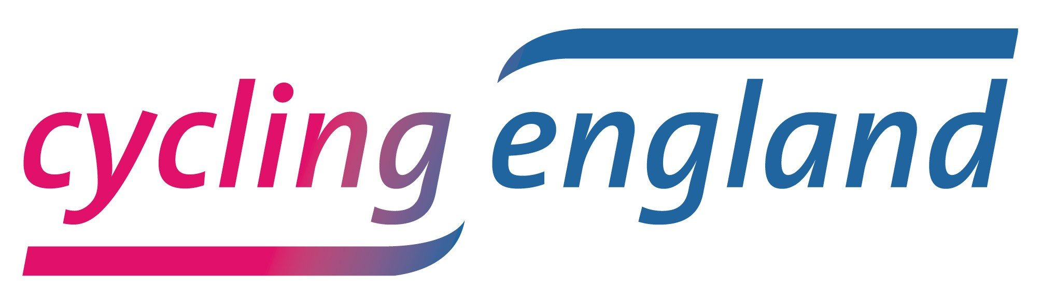

Action Notes

Board Meeting, 17th December 2008

Present

Board:

Phillip Darnton
Lynn Sloman
Chris Spencer
Dave Merrett
Christian Wolmar
Kevin Mayne
Alison Hill
Malcolm Shepherd
Peter King
CE Staff:

Steve Garidis
Paul Robison
Tricia Allen

Notes:

- Peter King announced he had stepped down as Chief Executive of British Cycling and now had a new role as Executive Director. Ian Drake had taken over as the new Chief Executive of British Cycling. Peter would remain on the board of Cycling England.

- Tricia Allen gave an update on progress in the Cycling Towns and Cities (CCT) programme:

  - 10 of 12 work plans from the towns had been approved by the CCT programme board. 2 were in the final stages of approval.

  - It was noted that many CCTs still had interim project managers in place, and this meant some CCTs were not fully geared-up for delivery yet. The Board noted that contingency plans should be in place should any CCT look unlikely to deliver on its proposals and work plans in 2009.
Action: CCT programme board to consider contingency plans for failure of 1 or more CCTs during 2009.

  - There was discussion around the various towns’ Local Area Agreements (LAAs). The meeting recommended checking that each LAA supported the CCT’s strategy and work plan (e.g. by having the right objectives and indicators).
Action: Tricia Allen to investigate LAA objectives in the towns and cities.

  - The Board queried the level of political engagement the programme had with local CCT councillors. It was noted that plans were in place via strategic board member engagements and more general support from the Professional Support team.

  - The monitoring team led by the Sustrans had begun visiting CCTs to establish a monitoring plan for each. Separately, work was being developed to establish ‘lessons learned’ in the original 6 Demonstration Towns in a format (such as filmed interviews) which allowed quick and easy uptake by new CCTs.

  - The board queried whether any CE funds should be spent by the CCTs on the Tour of Britain.
Action: Phillip to send letter to towns explaining what level of funding and support CE expected for various events-type activities e.g. ToB

- Paul Robison gave an update on the Schools programme describing in particular the marketing plans for 2009 to be ‘the Year of Bikeability’ – a major campaign running throughout 2009 to promote Bikeability to schools, parents, teachers and children. The Board approved the plans. It was suggested that in addition to planned national events such as the Education show at the NEC, there were other regional shows which linked in well with some of the CCTs. E.g. the North of England Education Show was to be held in Chester in 2009 and in York in 2010.
Action: Paul to investigate regional opportunities with Blue Rubicon

- Steve Garidis took the Board through the latest proposals for Finding New Solutions covering potential projects under the headings bike & rail; bike & leisure; and the journey to work. The Board discussed the idea of finding ‘hubs’ where a package of measures could be focussed on a variety of trips and a variety of target audiences. This was what made ‘schools’ and ‘towns’ effective as programmes. Railway stations, leisure ‘destinations’ such as national parks were discussed as well as further / higher education within the context of the trip to work. The Board also discussed the potential for Local Strategic Partnerships (LSPs) to be used to deliver a package of interventions encompassing all three areas discussed above.
Action: Steve Garidis to investigate the potential for LSPs to be used as a delivery mechanism for the ‘Finding New Solutions’ programme

- Future Meetings: The Board agreed it would be desirable to hold some Board meetings within the Cycling Towns and Cities to enable better engagement between the CE Board and senior officers and political champions within towns.

